**Membership Modules**

1.Login

2.User

3.Dashboard

4.Masters

5.Membership

**Modules Description**

**3.Master Module**

This module is designed to be used to stores the user's basic information and it contains 12 subcategories that are used to stores the user's basic information. This Allows Union user’s to maintain, update, view and delete the corresponding records.

12 Subcategories are,

* Country Details
* State Details
* City Details
* Status Details
* Company Details
* Union Branch Details
* Company Branch Details
* Designation Details
* Race Details
* Person Title Details
* Relation Details
* Form Type Details

1.Country Details

The country details helps to store ,update and delete the country details

**1. Country List [English Version]**

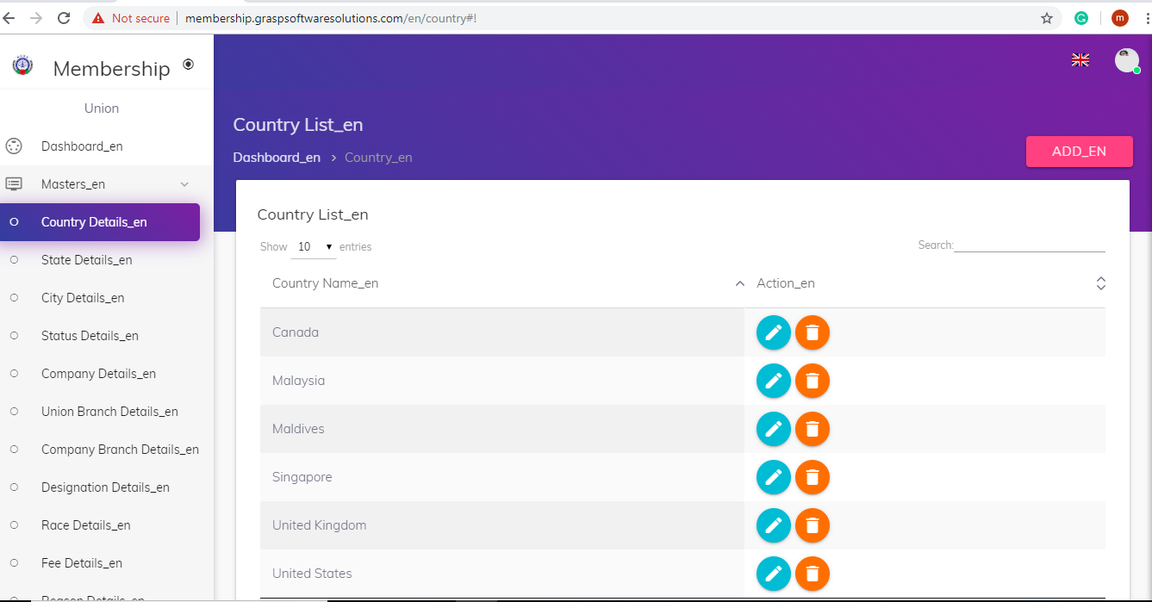

**Add Country**

Enter the Country name here it will check the exists of country name, If the country is not exists then the country name will be stored.

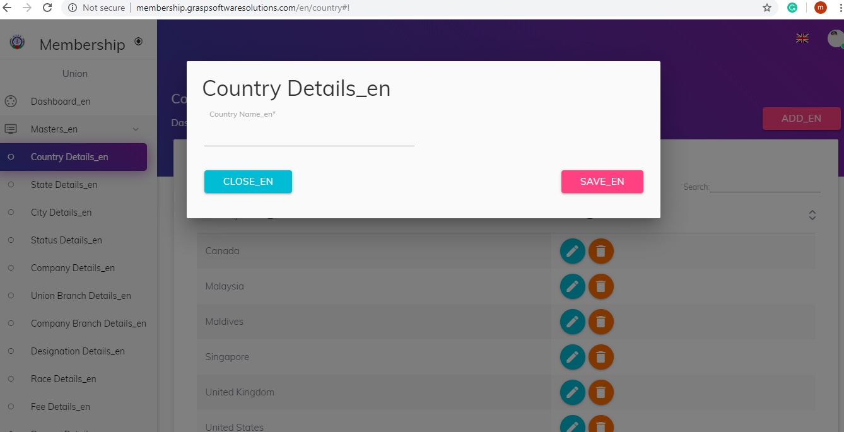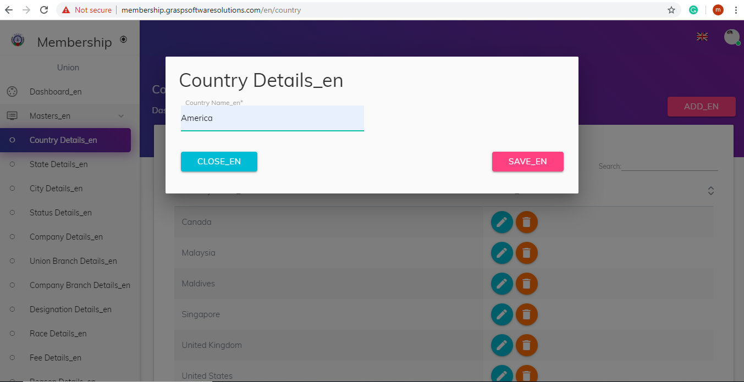

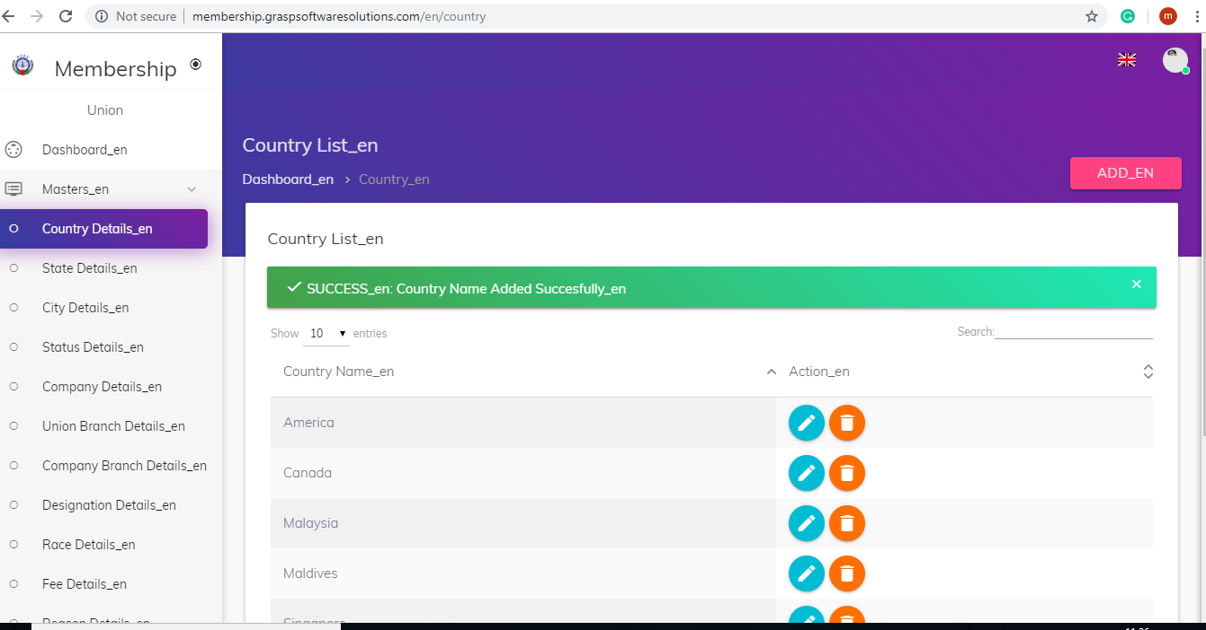

**Exists Check**

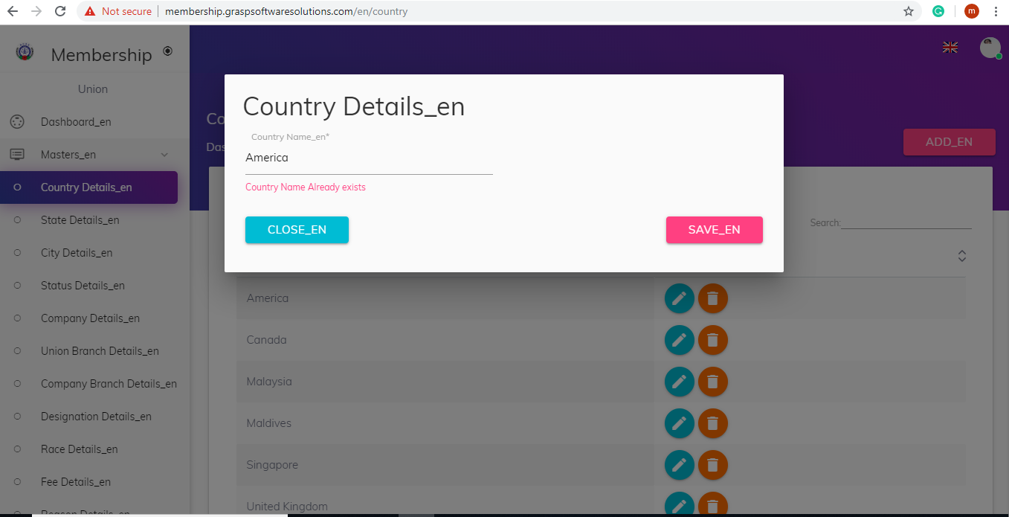

**Required Fields Check**

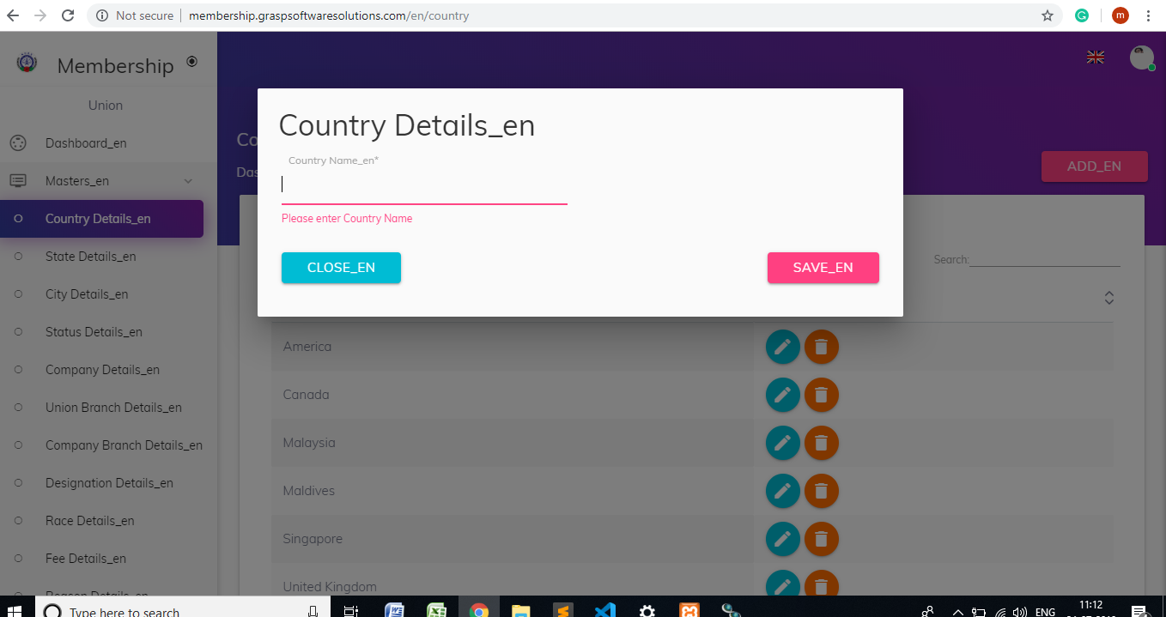

**Update Country**

User can update the country name whenever they want.

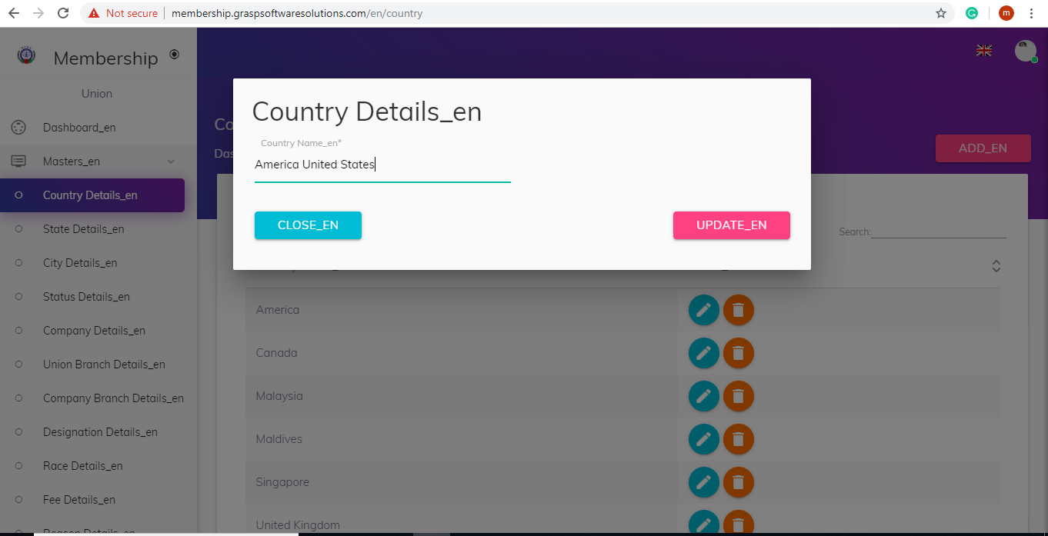

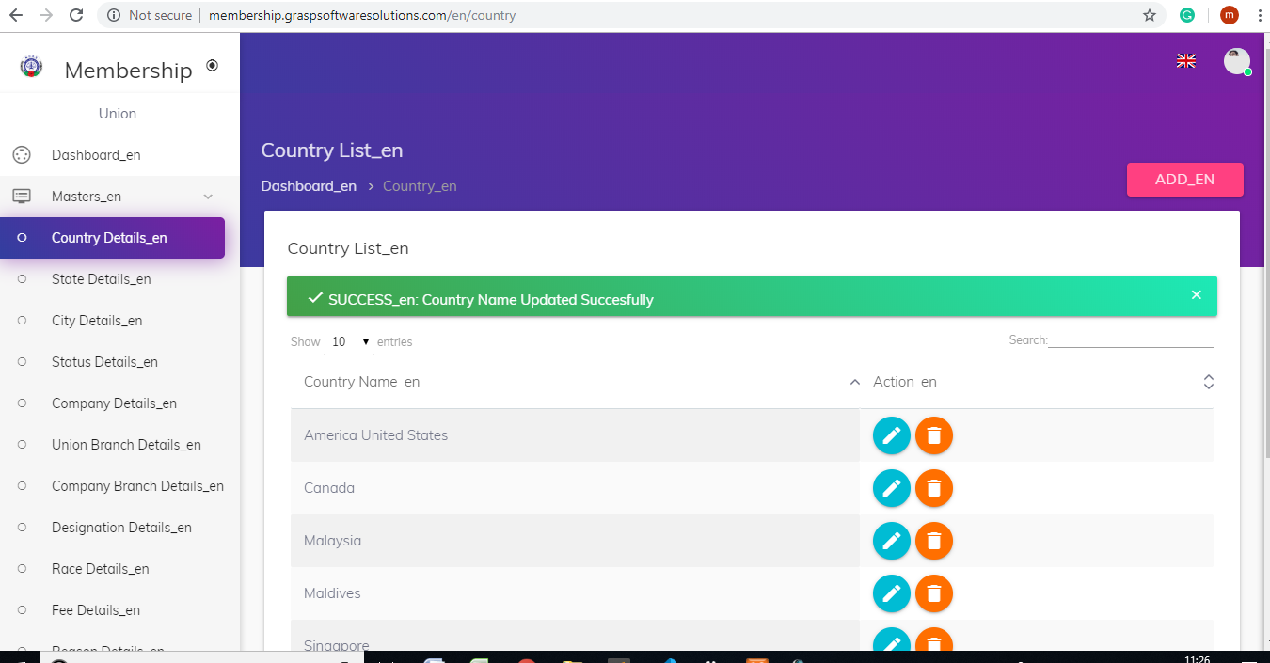

**Delete Country**

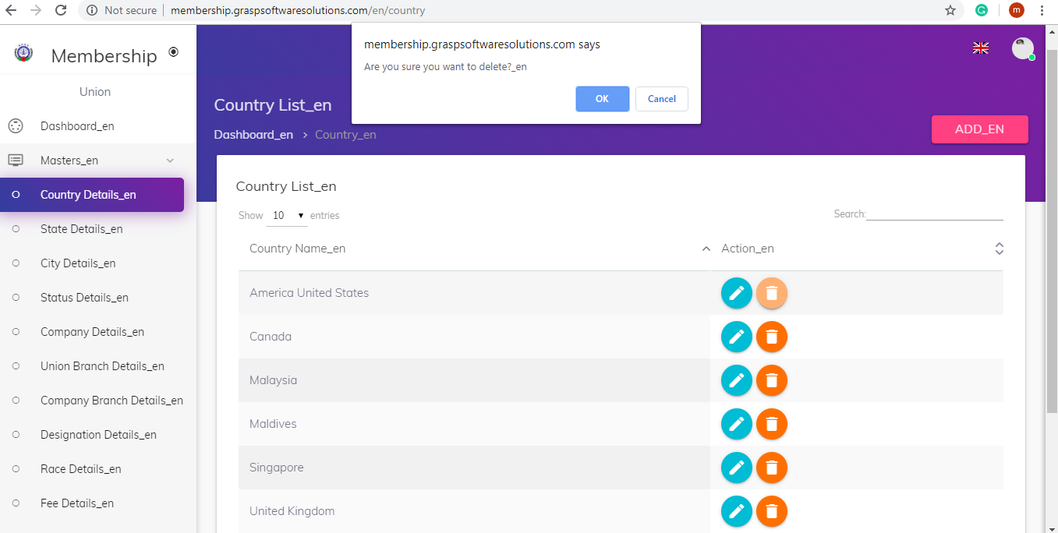

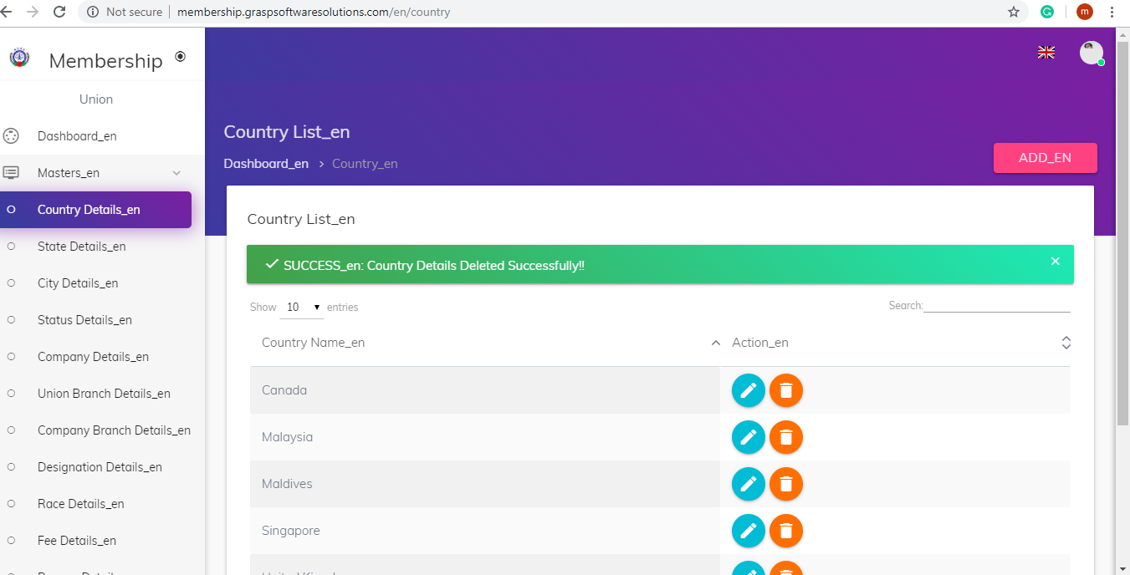

After deleting the company the page will be redirected to Country List page.

**2.State Details**

The State details helps to store ,update, View and delete the State details.

**1.State List(View)**

State List

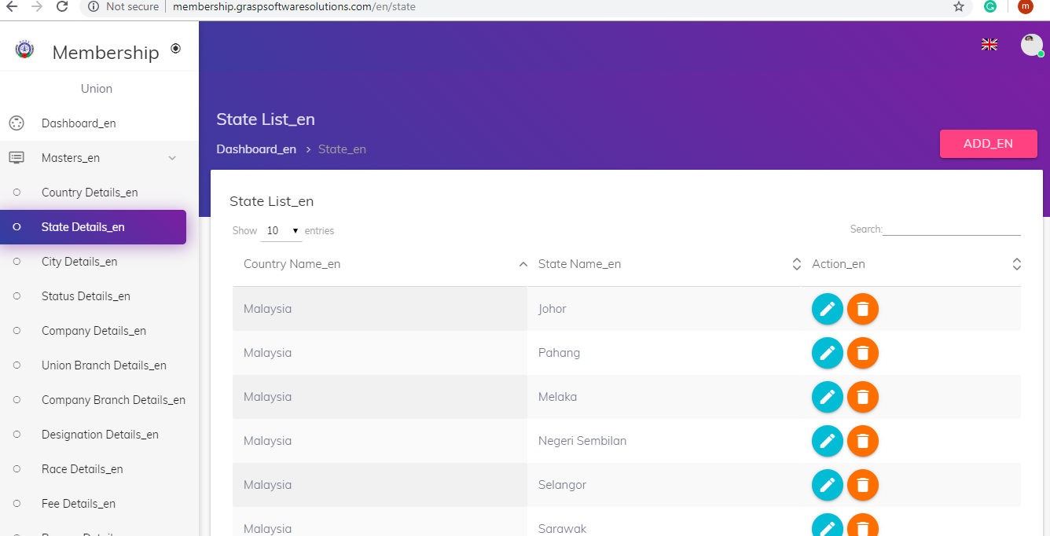

**2.Add State**

Default Country : Malaysia

Required Fileds : Country Name, State Name